RISHITHA’S PORTFOLIO WEBSITE

### **DISCRIPTION:-**

This is a responsive and interactive personal portfolio website used to showcase my skills ,contact information and to provide an easy way of recruiters and collaborators to connect.

CORE MODULES:-

1. Introduction (home)
2. About me section
3. Skills
4. Contact form
5. Social media links
6. Downloadable resume

tech stack used:-

1.HTML – for structure and content

2.CSS - for styling and layout

3.JAVA SCRIPT – for interactivity

4.FONT AWESOME – for social media icons

5.GOOGLE FONTS – for modern typography

FEATURES:-

1. responsive design for mobile ,tablet and desktop
2. sticky and bold navbar

# html code:-

### <head> **Section**

* Sets character encoding and responsive design.
* Defines the title of the webpage.
* Links the custom stylesheet (style.css) and **Font Awesome** for icons.

**🟦 Header Section**

**🧩 Components:**

* **Logo**: Displays an image using img tag.
* **Navigation Menu**:
  + Links to internal sections: Home, About, Contact.
* **Social Media Icons**:
  + GitHub, LinkedIn, Instagram using Font Awesome icons.

**🟦 Hero Text Section**

* Introduces the user with a job role and name.
* Includes a personal message with location.

**🟩 About Section**

**🧩 Layout:**

* Split into two columns:
  + **Image column**: Displays a personal photo.
  + **Text column**: Describes the user and includes skills and education tabs.

**🧪 Tabs with JavaScript:**

Controlled using class toggling on click (active-link, active-tab).

**🟨 Contact Section**

**🔸 Left Side:**

* Displays contact information (email and phone).
* Provides a **resume download** button.

**🔸 Right Side:**

* A contact form using:
  + <input> fields for name and email.
  + <textarea> for message.
  + Submit button styled with a class.

**📬 Form Submission to Google Sheets:**

* Submits data via fetch() to a Google Script.
* Displays success message using a <span id="msg">.

**🟥 Footer**

* Simple footer with a copyright.

# css code:-

**1. Global Styles**

* **Resets** default browser styling.
* Sets a consistent font-family.
* Enables **smooth scrolling** for internal links.
* Uses a **dark theme** with light text for contrast.

**🔹 2. Header Section**

* Covers full screen height.
* Uses a **background image** for visual appeal.
* Padding for inner spacing.
* Adds **extra padding** on large screens for better layout.

**🔹 3. Navigation Bar (nav)**

Flex layout for responsive nav bar.

* Circular logo with border-radius: 50%.
* Stylish **underline animation** for links.
* Adds visual feedback on hover.

**🔹 4. Hero Text**

* Bold intro message with a highlighted name.

**🔹 5. About Section**

* Responsive two-column layout.
* **Image column** and **text column** with flex properties.
* Large section heading.

**➤ Tabs: Skills and Education**

* Tabs switch content dynamically using JavaScript.
* Active tabs get a colored underline.

**🔹 6. Contact Section**

* Form elements are styled with dark backgrounds and white text.
* **Responsive layout** ensures mobile stacking.
* Adjusts layout for smaller screens.

**🔹 7. Footer**

* Minimalist footer with a dark background and soft borders.

**🔹 8. Message Feedback**

* Shows feedback after form submission (success message).

**🔹 9. Social Media Icons**

* Icons are enlarged for emphasis and change color on hover.

LIVE DEMO :-

Link : [Rishitha portfolio](https://rishitha-portfolio-withcontact.netlify.app/)

**SCREEN SHOTS:-**

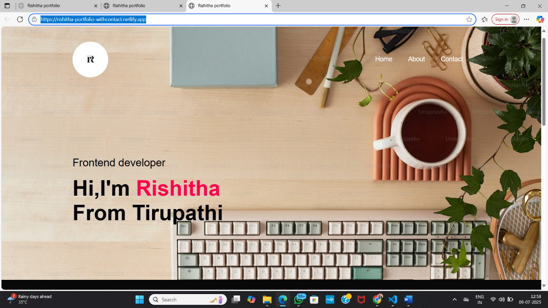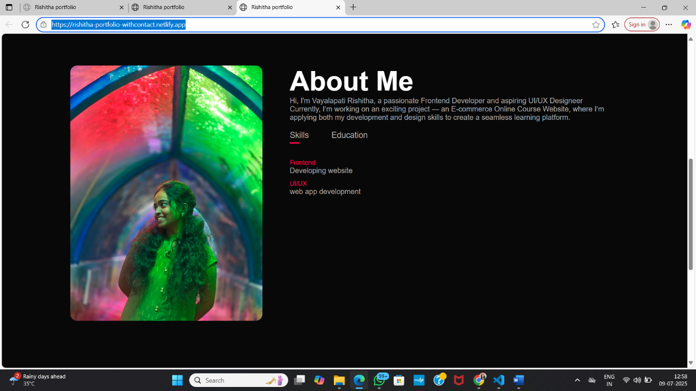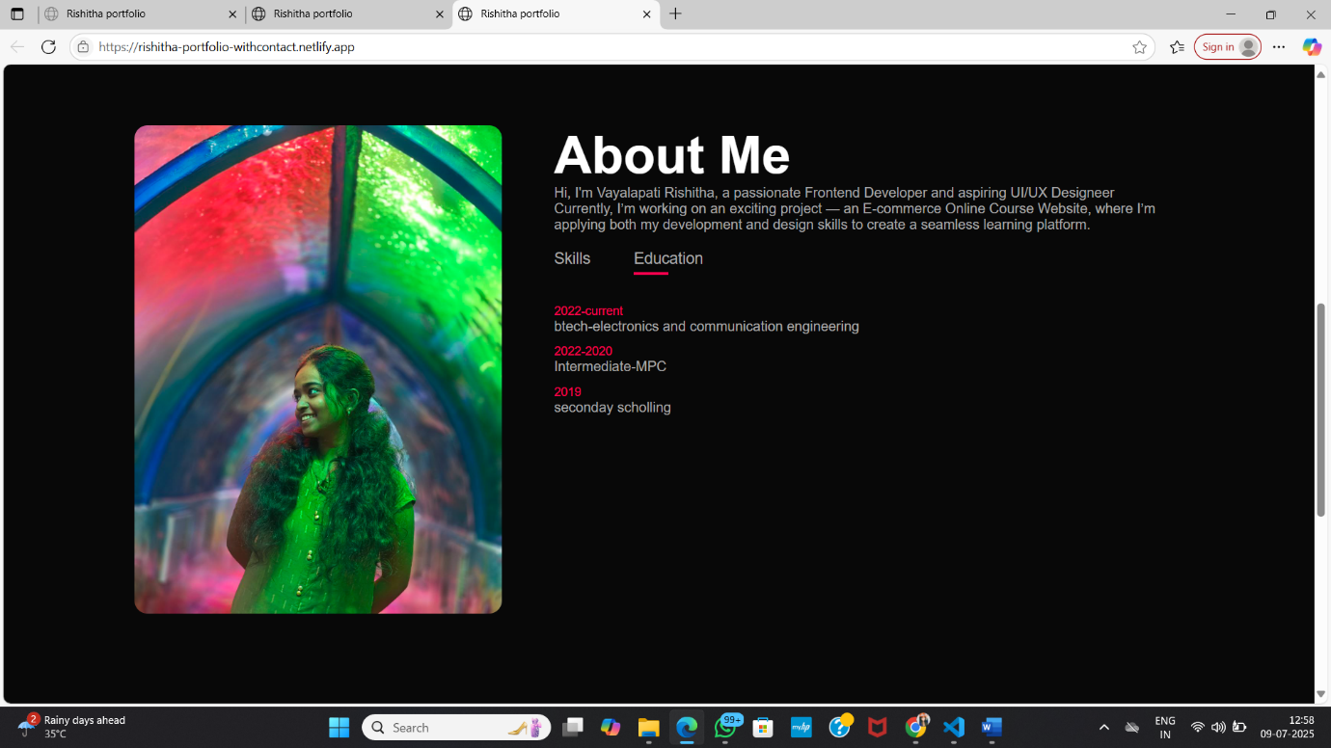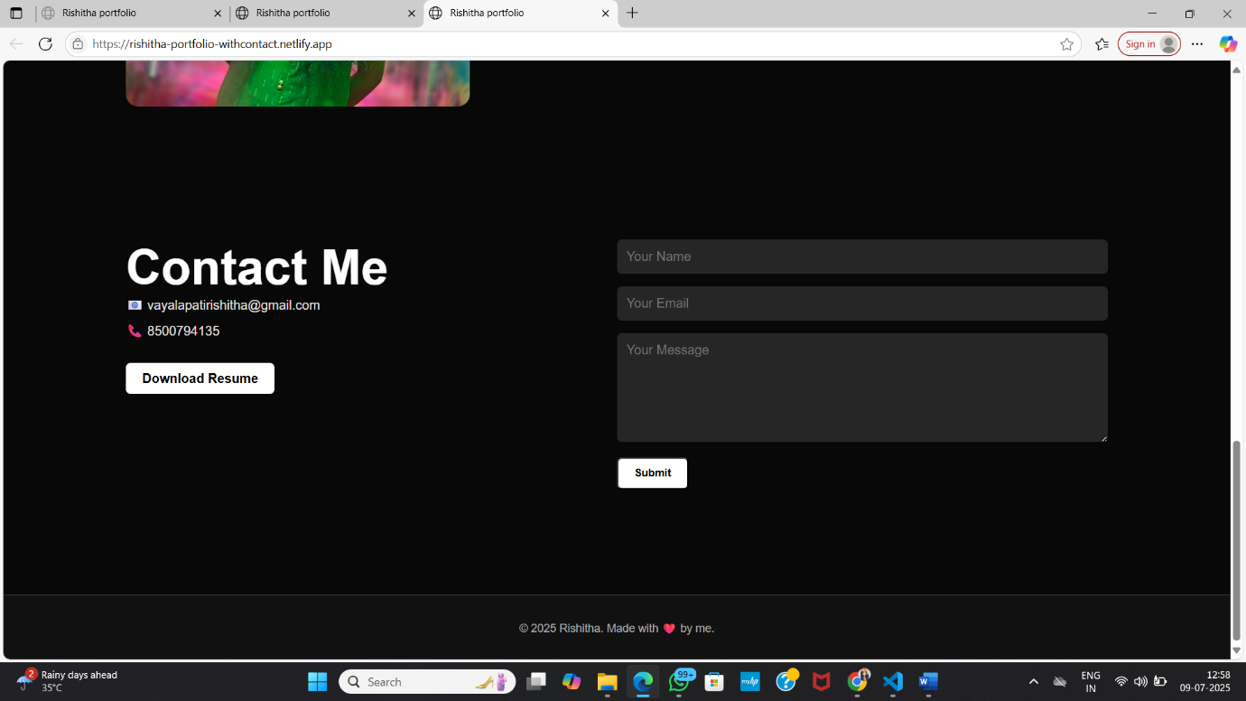

CONTACT ME :-

🌐 [LinkedIn](https://www.linkedin.com/in/vayalapati-rishitha-74ba04275/)

💻 [GitHub](https://github.com/Rishitha8998)

📧 vayalapatirishitha@gmail.com

📞 Phone: +91-8500794135